WEBSITE ITOOLS

1. **Login screen :**

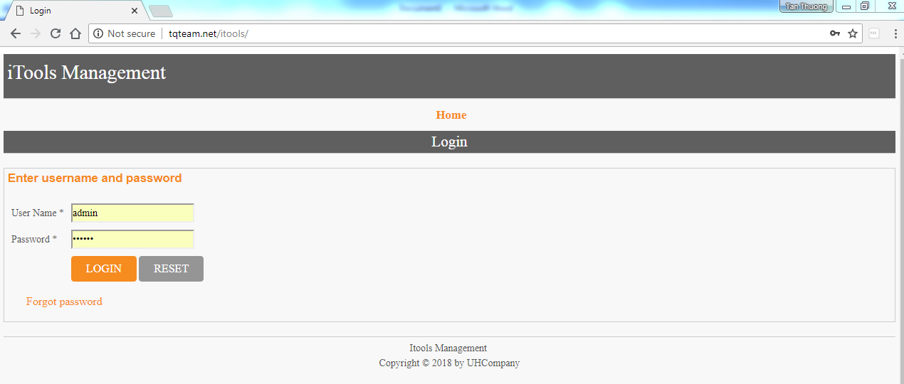

* 1. **Login function :**
* Input username
* Input password
* Click on Login button and go to Machine Screen.
  1. **Reset function :**
* Click on reset button and clear all data in username and password.
  1. **Forgot password function :**
* Click on Forgot password for receive a new password for selected user. ( view Forgot Password Screen)

1. **Forgot password screen :**

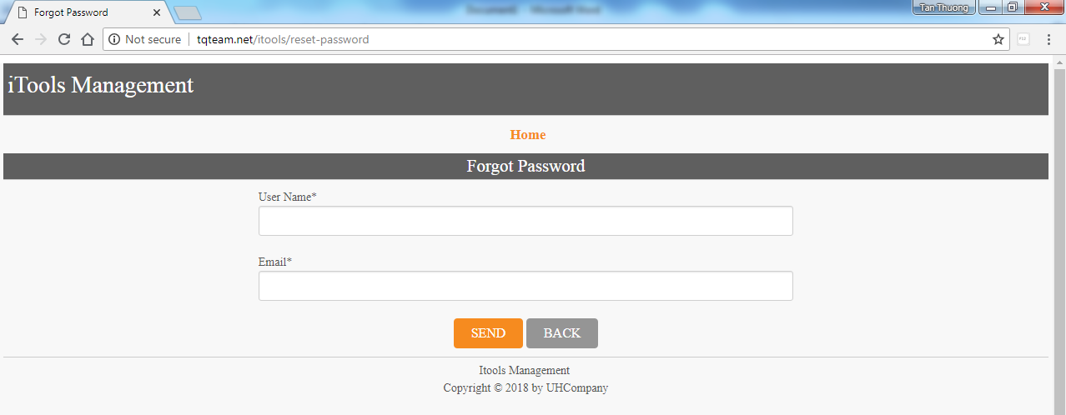

* Input username
* Input email address of this user.
* Click on Send button and a new password will be sent to email address of input user.

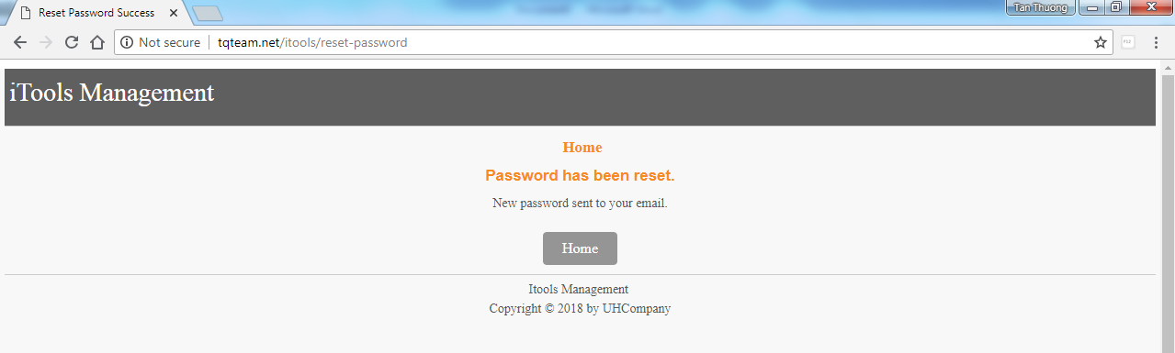

* If input email address of input user is not valid, error message will be display.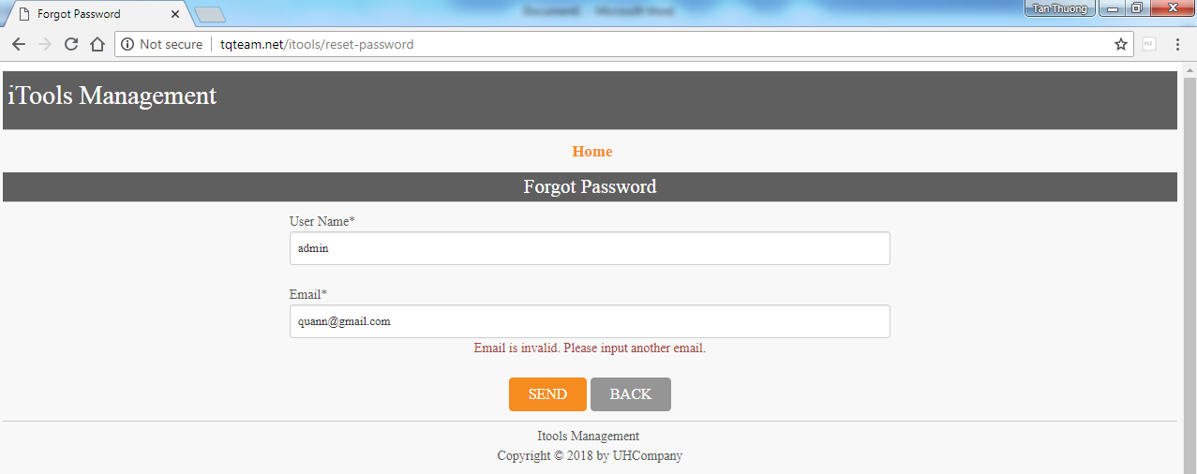
* If input a user is not exist, error message will be display. 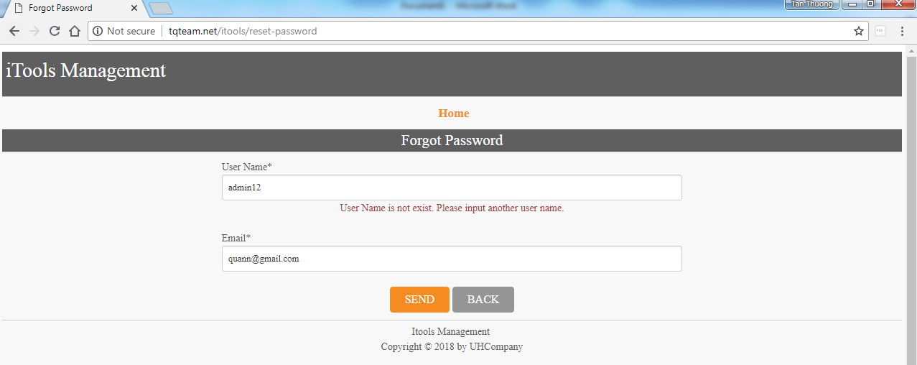
* Click Back and return login screen.